The Coding Manual

# 1 Coding Manual Instruction

The primary aim of this coding manual was to standardize the coding procedure and eliminate inconsistencies across coders.

# 2 Coding Procedure

The whole process of coding is divided into two stages: coding stage and proofreading stage.

2.1 Coding Stage

1000 articles

Reading the method part

For the target literature, extracting its complete information

For studies that used large-database and animals, only extracting article information

Reading the abstract, discussion or conclusion and coding for sampling restrictiveness and generalizability of their results or conclusion

Figure 1. The procedure of the coding stage

2.1.1 Method Part

Firstly, we will read the method part to check whether the study used data from large database or animals. If yes, we will only record the article information. If no, we will code based on our manual in **section 3**.

For those studies used large datasets or animals, we will record information below (see Figure 2.).

Taking “*Time trends and group differences in public tolerance toward homosexual behavior in China”* as an example, the method part describes this study as a database study. The coding example as follows:

* + Article IDs: 23031
  + Source journal: *Chinese Journal of Clinical Psychology*
  + Article title: Time trends and group differences in public tolerance toward homosexual behavior in China
  + Study number: 1
  + Study type: questionnaire
  + Remark: database

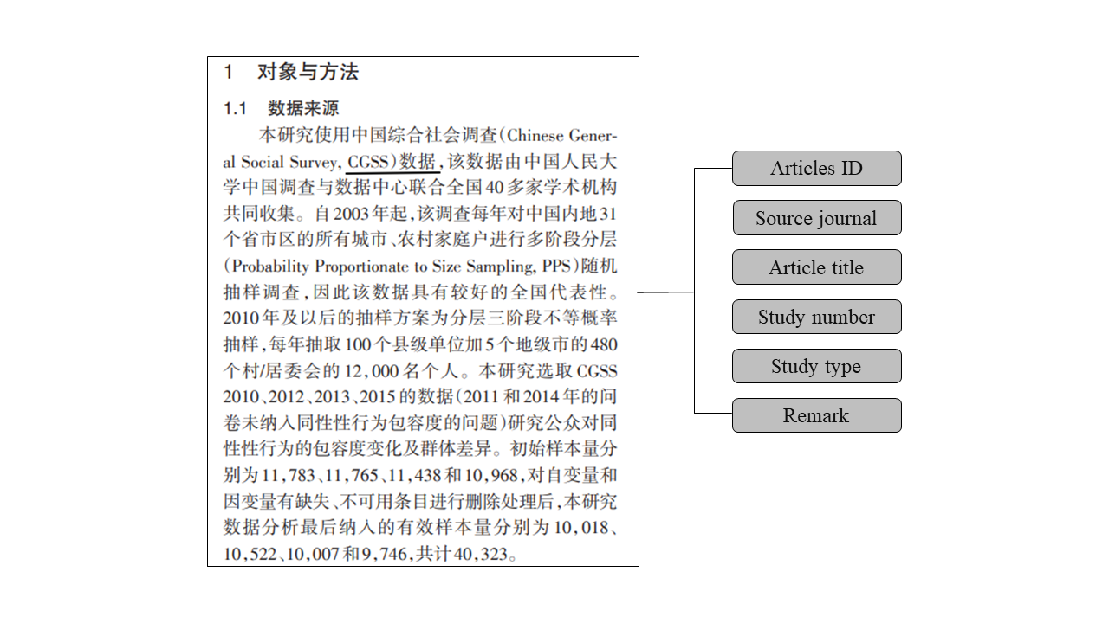

Figure 2. The example of article information.

For other articles, we will extract information about participants (see Figure 3.).

Taking “*Imagination inflation effect in older adults”* as an example, the coding example as follows:

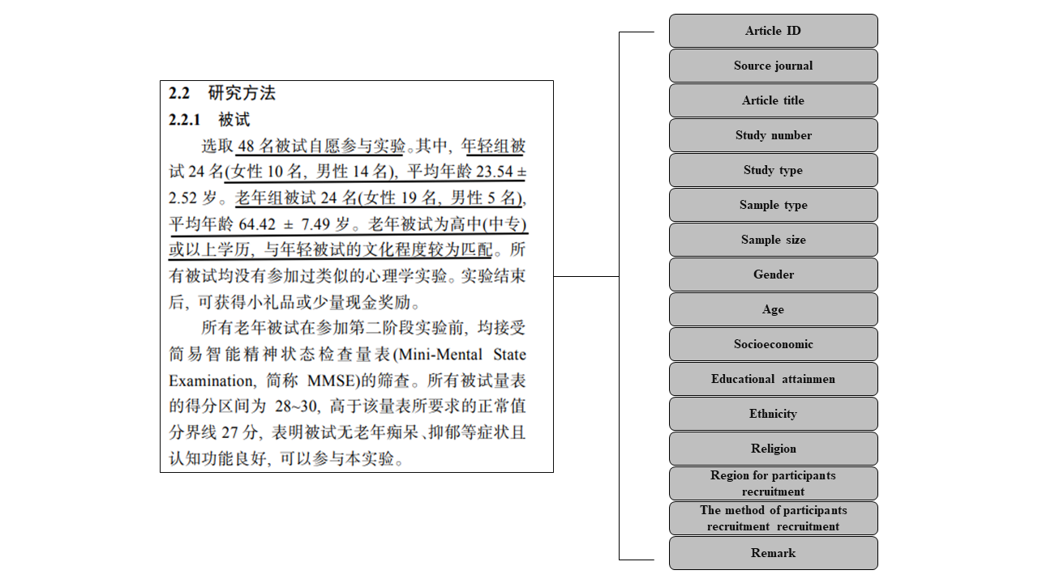

* Figure 3. The example of participants complete information.
  + Article ID: 21005
  + Source journal: *Acta Psychological Sinica*
  + Article title: Imagination inflation effect in older adults
  + Study number: 1
  + Study type: experiment
  + Sample type: other
  + Sample size: 48
  + Gender：
    - reported
    - female: 19; male: 29
  + Age:
    - reported
    - 23.54±2.52; 64.42±7.49
  + Socioeconomic: unreported
  + Educational attainmen:
    - reported
    - senior high school and above
  + Ethnicity: unreported
  + Occupation: unreported
  + Religion: unreported
  + Region for participants recruitment: unreported
  + The method of subjects recruitment: unreported
  + Remark: noting

2.1.2 Abstract, Result, Discussion/Conclusion Part

In addition, we will also read the abstract, discussion and conclusion for those articles that we extract participants’ information. In these parts, we will extract description of the authors’ claims about the generalizability of their results or conclusion.

2.2 Coding Proofreading

(1) We will redistribute the articles for proofreading to further increase the reliability and objectivity of the coding content after the coding stage.

(2) If there is inconsistency between two independent coders, we will go back to the article and resolve the inconsistency through discussion. If agreement can not be achieve between two coders, a third coder, a senior author, will join the discussion to make a final decision.

# 3 The Detailed Information of Code Dimensions

* **Article IDs:** each article have diffirent IDs (8 digits)
* **Source journal:** 
  + *Acta Psychological Sinica, Journal of Psychological Science, Chinese Journal of Clinical Psychology, Psychological Development and Education, Psychological and Behavioral Studies*
* **Article title**
* **Study number：**which study in this article
* **Study type:**
  + experiment / quasi-experiment / questionnaire / others
* **Sample type:**
  + university students / non-university students / others
* **Sample size：**valid sample
* **Gender:**
  + reported / unreported
  + if reported, extract the number of females (males)
* **Age:**
  + reported / unreported
  + if reported, extract the mean and SD or range
* **Socioeconomic:** objective social status or subjective social status
  + reported / unreported
  + if reported, extract the SES information
* **Educational attainment：**
  + reported / unreported
  + if reported, extract the educational attainment information
* **Ethnicity:**
  + reported / unreported
  + if reported, extract the ethnicity information
  + if reported, document whether it is an ethnopsychological study or a non-ethnopsychological study
* **Occupation:**
  + reported / unreported
  + if reported, extract this information
* **Religion:**
  + reported / unreported
  + if reported, extract this information
* **Area[1]：**
  + provincial area / non-Chinese sample / unreported
* **The method of subjects recruitment:**
  + online/offline/online and offline/unreported
* Remark:

Database data studies are noted as database; animal studies are noted as animal. In addition, coders can record what they want to record when they coding.

* **Abstract[2]：**
  + reported / unreported
* **Conclusion：**
  + specific /generalize
* **Discussion：**
  + detailed / proforma / absent

# Reference

Rad, M. S., Martingano, A. J., & Ginges, J. (2018). Toward a psychology of Homo sapiens: Making psychological science more representative of the human population. *Proceedings of the National Academy of Sciences*, *115*(45), 11401–11405. <https://doi.org/10.1073/pnas.1721165115>

1. If a study contains multiple region, each area is counted separately.
2. See Rad et al. (2018) for the coding criterion of abstract, conclusion and discussion.